embargo until april 6, 2021 AT 6:01 AM CENTRAL EUROPEAN SUMMER TIME

BluOS Expands Music Streaming Services and Becomes the First to Bring MQA Content to Internet Radio
  - BluOS 3.14 Brings Exclusive Access to Radio Paradise MQA Audio Streams and Adds New Consumer and Business Streaming Services

PICKERING, ONTARIO, CANADA, April 6, 2021 – BluOS®, the premium multi-room music management platform by Lenbrook International, has announced a number of enhancements that will come with today’s release of version 3.14. Users will be prompted to update their BluOS players, at which time they will gain access to three new natively-integrated streaming services, exclusive access to Radio Paradise MQA-encoded audio streams and various performance improvements. The BluOS 3.14 update supports all BluOS Enabled devices from NAD Electronics, Bluesound, DALI Loudspeakers, Monitor Audio, and future products from Peachtree Audio, Roksan and PSB Speakers.

New Streaming Services
Spotify (Free version), SiriusXM and SiriusXM Music for Business join more than 20 other streaming services already available to BluOS users, expanding the variety and sources of audio content that can be enjoyed on BluOS Enabled products.

BluOS, Radio Paradise and MQA Partner to Deliver BluOS Users Exclusive MQA-Encoded Content

Effective with the BluOS 3.14 software update, BluOS user globally will have exclusive access to Radio Paradise MQA-encoded audio, utilizing high-resolution 24-bit masters where available. Radio Paradise is an independent, listener-supported Internet radio service with a focus on providing the highest quality audio experience to a passionate worldwide audience. This collaboration marks the first time an internet radio station will carry MQA-encoded content.

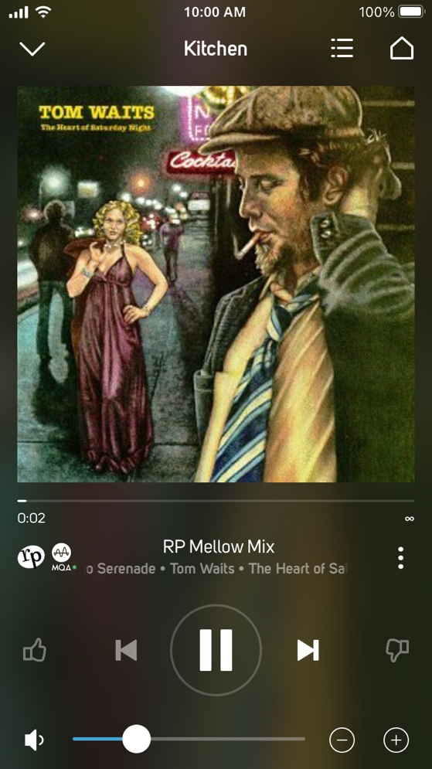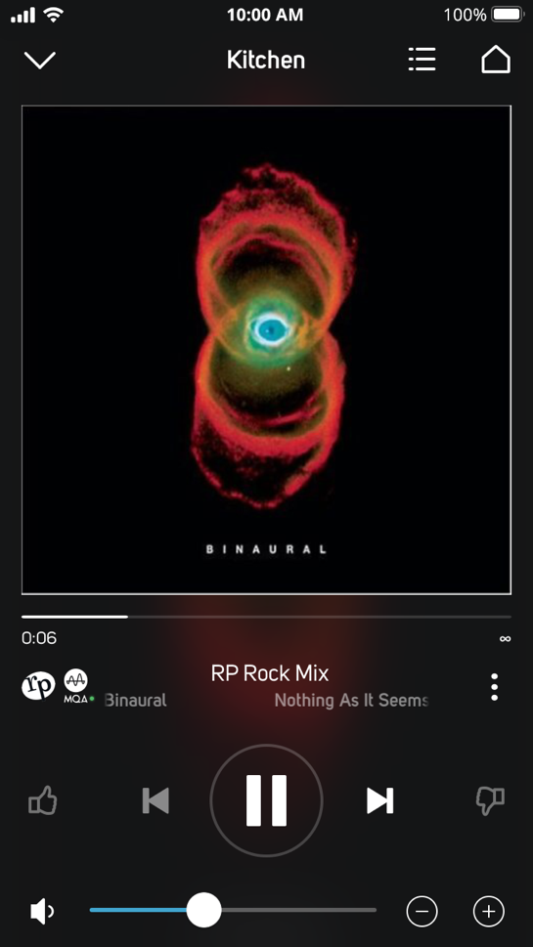
Radio Paradise MQA RP Mellow Mix (left) and RP Rock Mix Now Playing Screenshots

Spotify (Free version)
In addition to Spotify Premium currently offered to BluOS users, we are pleased to now support the free version of Spotify. Spotify is one of the world’s largest music streaming service providers and features a library of more than 70 million songs. Spotify makes it easy to listen to the songs you love, discover new music and podcasts and creates personalized playlists.
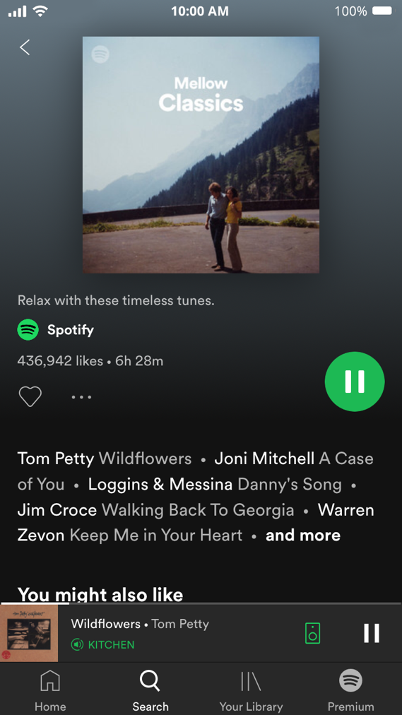
Spotify (Free version) Mellow Classics Now Playing Screenshot

SiriusXM (For USA and Canada)

The integration of SiriusXM, the largest audio entertainment company in North America, allows BluOS users in the USA and Canada who are SiriusXM subscribers the ability to browse and select from hundreds of channels of commercial-free music, premier sports talk and live events, and the latest local and world news, on demand, from within the BluOS app.

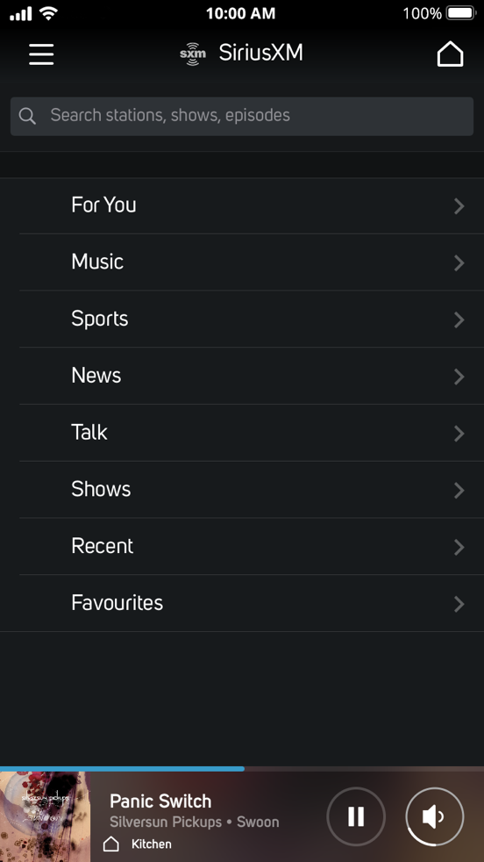
SiriusXM Menu Screenshot

SiriusXM Music for Business (For USA and Canada)

With BluOS 3.14, Bluesound Professional, the premium distributed audio ecosystem for commercial spaces adds SiriusXM Music for Business to its growing list of commercially licensed streaming music partners. Available to SiriusXM Music for Business subscribers in the USA and Canada, the service offers Bluesound Professional users a curated, licensed audio content to enhance client experiences in retail, hospitality and other commercial spaces.

Other Feature/Maintenance Improvements

The BluOS 3.14 release also includes various feature/maintenance improvements. These include:

- NAD M33 and T 778 are Roon Ready for music management and streaming
- New, more intuitive play queue design that deepens the listening experience with enhanced visuals
- Roon improvements for grouping and signal path reporting
- Updates to TIDAL, Qobuz, Amazon Music and Deezer
- Improvements to library indexing for file permissions and handling unreadable audio files
- Performance improvements for WiFi

About bluOS
BluOS™ is a premium multi-room audio ecosystem that manages stored and cloud music sources and playback, with support for high-resolution audio streams up to 24/192. Adopted by some of the most renowned hifi audio brands and integrated with numerous smarthome and voice control systems, BluOS allows for interoperability among enabled devices across brands for maximum versatility and use cases. Integrations with popular streaming music services like Tidal, Spotify, and Deezer, as well as featuring support for FLAC, WAV, MQA, and other high-resolution formats and codecs, BluOS offers virtually unlimited access to music of all genres for any occasion. Made up of an operating system and a control application for smart phones, tablets, and PC desktops, BluOS is the ultimate choice for the modern audiophile.

Contacts

Corporate Contact
Mark Stone
Marketing, Lenbrook International
mstone@lenbrook.com

US Media Relations
Jeff Touzeau (OLEX Communications)
jeff@olexcommunications.us

UK Media Relations
Steve Dalton
steve@olexcommunications.co.uk

Links
BluOS: https://bluos.net
Lenbrook: https://lenbrook.com
Images: https://bluos.webdamdb.com/bp/#/folder/9454984/

# # #

